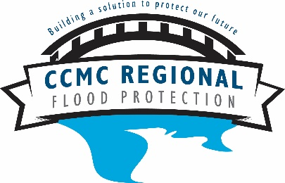

CCMC Flood Control Project Steering Committee
March 26, 2019

The CCMC Flood Control Project Steering Committee met Tuesday, March 26, 2019, at 1:30 p.m. in City Hall. Present were Committee Members Floodplain Administrator (FPA) Samantha Malenovsky, Public Works Director (PWD) Scott Gray, Custer County Commissioner (CC) Jason Strouf, and (KLJ) Becky Bey. Councilperson (CP) Jeff Earlenbusch and (KLJ) Carl Jackson were absent.

- General Discussion
- FPA Malenovsky discussed the upcoming Flood Awareness Day scheduled for April 16. Dan Richardson from KLJ will discuss the slough project and Chris Fassero with USACE will present on the Section 205 update.
- Also discussed was the USACE meeting that took place December 10th and 11th.
- Alternatives were discussed and sorted based on feasibility and other available resources.
- Chris Fassero projected that by the October 2019 public meeting alternatives with preferred options and associated cost would be presented.
- Becky Bey reported the next CCMC newsletter is scheduled for April. We will highlight the slough project and Flood Awareness Day.

- Adjournment
- There being no further business, the Committee adjourned at 1:50 pm.

Action Items: None

Respectfully Submitted,

______________________________
Samantha Malenovsky, Flood Control Project
Steering Committee Chairperson and Recorder

